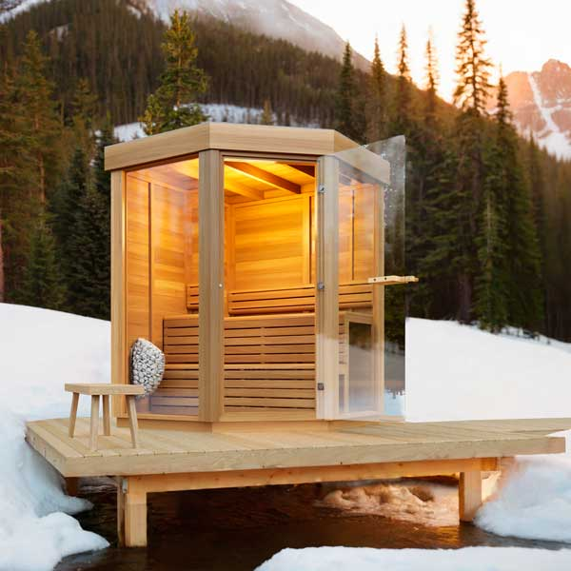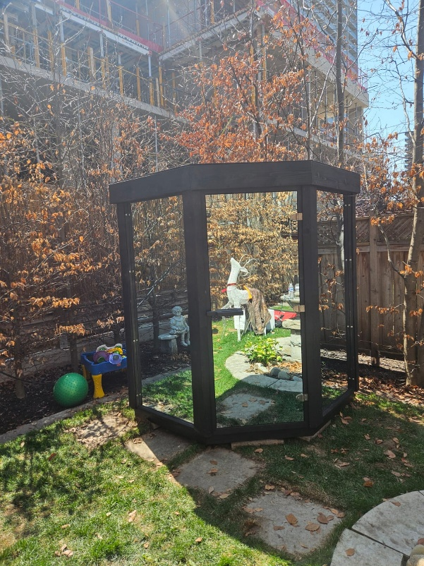

Model: Trinity from the Pure Cube Collection

Wood: Western Red Cedar Knotty

Footprint Size: 5’ wide x 5’ deep

Bench Configuration: Two Tier back wall

Options: Bronze glass
Semi-privacy panels with bronze glass
Mirror glass panels

Heater options:
Electric only
Wifi electric or non-wifi electric
Electric requires 220 volt and typically 30 or 40 amp, depending on the size of heater

5- year Residential Warranty


Dundalk LeisureCraft Inc.
318448 8th Line, Melancthon, Ontario Canada L9V 2K3
Ph: 519-923-9813 | Fax: 866-458-7583 | Web: www.leisurecraft.com

