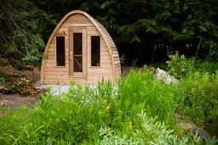

Model: Pod from the Dundalk Collection

Wood: Western Red Cedar Clear or Western Red Cedar Knotty

Footprint Size: Without porch

8’ wide x 6 deep, 8’ wide x 7’ deep, 8’wide by 8’ deep

With porch

8’ wide x 8’ deep, 8’ wide x 9’ deep, 8’ wide by 10’ deep

Bench Configuration:

Two Standard side wall benches

Two Signature Upgraded side wall benches

Two Tier back wall with L left return bench

Two Tier back wall with L right return bench

Window configuration:

Two windows front wall

Two windows on backwall over benches

Pod backwall window

Heater options:

Electric or wood heater

Wifi electric or non-wifi electric

Electric requires 220 volt and typically 30 or 40 amp, depending on the size of heater

Roof options:

Knotty Bevel roof

Clear Bevel roof

Cedar Shack roof

5 - year Residential Warranty

**Dundalk LeisureCraft Inc.**

318448 8th Line, Melancthon, Ontario Canada L9V 2K3

Ph: 519-923-9813 | Fax: 866-458-7583 | Web: [www.leisurecraft.com](http://www.leisurecraft.com)