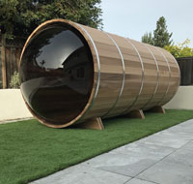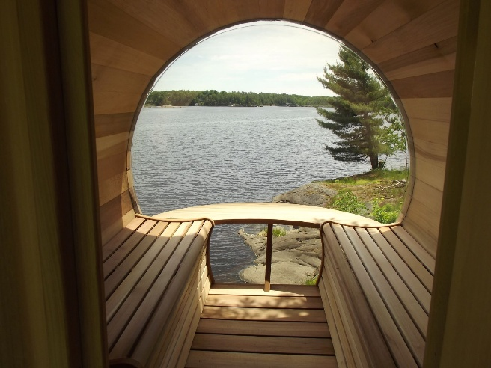

Model: Panoramic Barrel Saunas from the Dundalk Collection

Wood: Western Red Cedar Clear and western Red Cedar Knotty

Sauna Room Sizes: 7’ diameter x 6’ long, 7’ diameter x 7’ long, 7’ diameter by 8’ long

Options:
- 2’ porch
- 4’ Changing Room
- Roofs
  - Cedar Beveled or Black Metal
- Benches
  - Standard
  - Signature Upgraded (automatically comes with flat floor)
  - Two side wall benches, only
- Floor
  - No floor or with floor
- Overhang over front door (Baseball bill cap)
- Dome is Acrylic, do not heat sauna over 212 degrees F

Heater options:
Electric or wood heater
Wifi electric or non-wifi electric
Electric requires 220 volt and typically 30 or 40 amp, depending on the size of heater
Wood heater must sit on flat floor
Wood heater chimney must go thru roof

5 - year Residential Warranty

Dundalk LeisureCraft Inc.
318448 8th Line, Melancthon, Ontario Canada L9V 2K3

Ph: 519-923-9813 | Fax: 866-458-7583 | Web: www.leisurecraft.com

