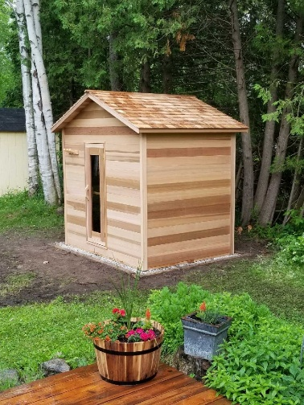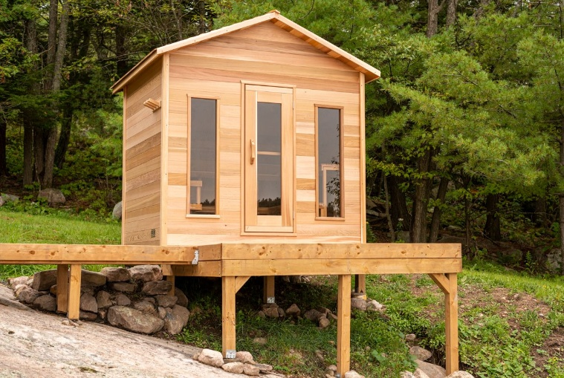

Model: Outdoor Cabin Saunas from the Dundalk Collection

Wood: Western Red Cedar Clear and western Red Cedar Knotty

Footprint Sizes: 5’x6’, 5’x7’, 5’x8’, 6’x4’, 6’x6’, 6’x7’, 6’x8’

Options:
- Benches (depending on sauna size)
  - Side wall, single tier
  - Side wall with either left or right return, single tier
  - Two tier back wall only
  - Two tier back wall with top tier side wall left or right
  - Fold Up Yoga bench (6x7 or 6x8)

- Windows (depending on size and bench configuration)
  - Door and two windows
  - Door and no windows
  - Door on Right with window on Left or Door on Left with window on Right

- Door
  - Can get 36” wide door in 6x8 size sauna only (no windows)

Heater options:
Electric or wood heater
Wifi electric or non-wifi electric
Electric requires 220 volt and typically 30 or 40 amp, depending on the size of heater
Wood heater must sit on flat floor
Wood heater chimney must go thru roof

5 - year Residential Warranty

Dundalk LeisureCraft Inc.
318448 8th Line, Melancthon, Ontario Canada L9V 2K3

Ph: 519-923-9813 | Fax: 866-458-7583 | Web: www.leisurecraft.com

