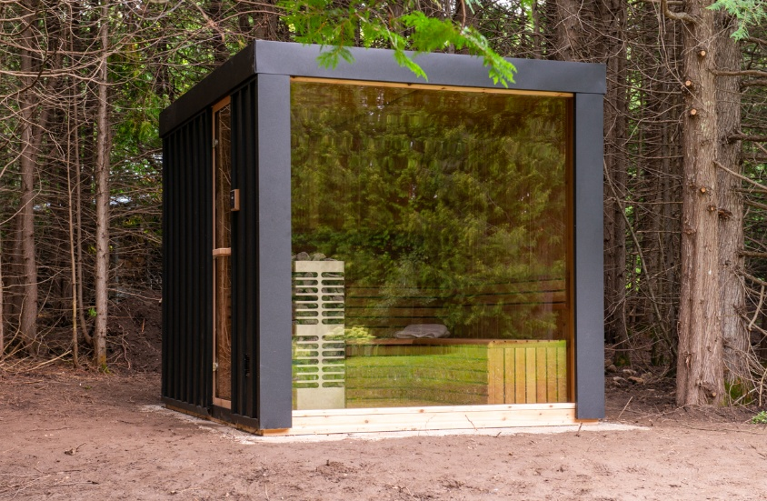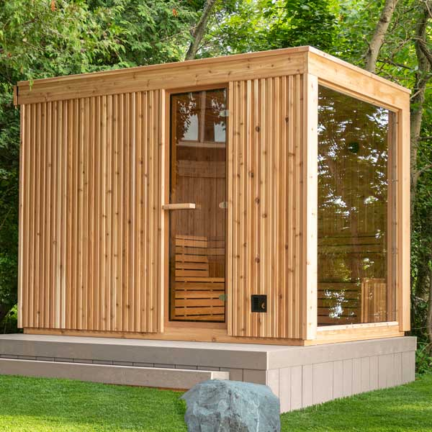

Model: Neptune from the Pure Cube Collection

Interior Wood: Western Red Cedar Clear or Western Red Cedar Knotty

Outside material: Black powder-coated steel or natural villa wood

Insulation: Included in the walls, floor and ceiling

Footprint Size: 8’ wide by 10’ deep

Bench Configuration:
Two Tier back wall
Optional L bench

Window:
Double paned 6mm thick
Optional mirror glass on front window and door

Heater options:
Electric or wood heater
Wifi electric or non-wifi electric
Electric requires 220 volt and typically 30 or 40 amp, depending on the size of heater

5 - year Residential Warranty


Dundalk LeisureCraft Inc.
318448 8th Line, Melancthon, Ontario Canada L9V 2K3
Ph: 519-923-9813 | Fax: 866-458-7583 | Web: www.leisurecraft.com

