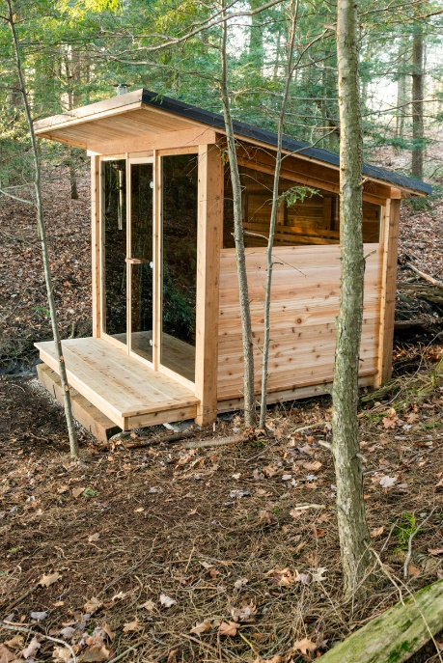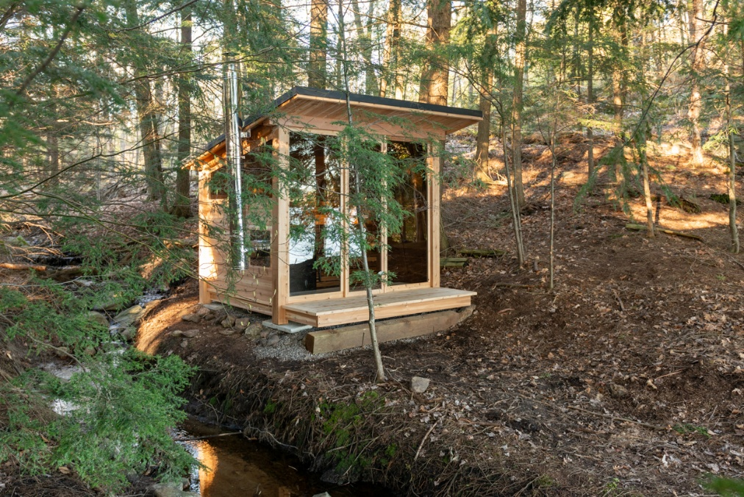

Model: Mountain View from the Pure Cube Collection

Wood: Western Red Cedar Knotty

Footprint Size: 8’ wide x 9’ deep x 8.5” high

Bench Configuration:
Two Tier back wall
Two tier backwall with left return
Two tier side wall benches

Window:
Bronze Double pane 5mm thick
Optional mirror glass on front window, door and side windows

Heater options:
Electric or wood heater
Wifi electric or non-wifi electric
Electric requires 220 volt and typically 30 or 40 amp, depending on the size of heater

5-year Residential Warranty


Dundalk LeisureCraft Inc.
318448 8th Line, Melancthon, Ontario Canada L9V 2K3
Ph: 519-923-9813 | Fax: 866-458-7583 | Web: www.leisurecraft.com

