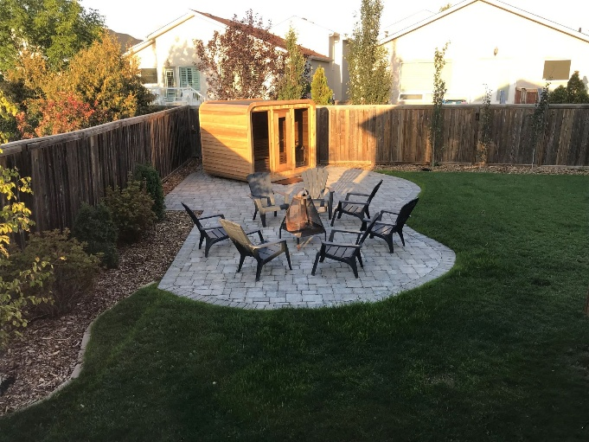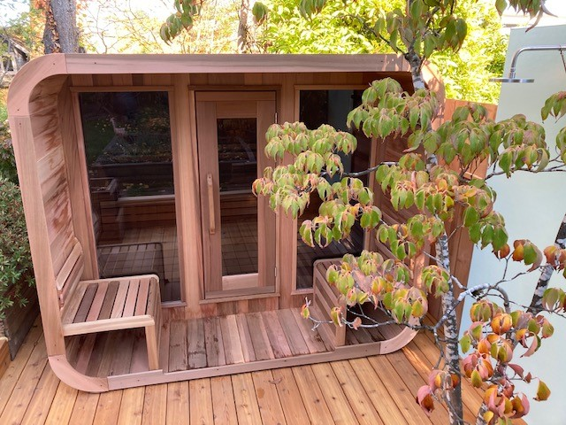

Model: Luna from the Dundalk Collection

Wood: Western Red Cedar Clear or Western Red Cedar Knotty

Footprint Size: Without porch
8’ wide x 6 deep, 8’ wide x 7’ deep, 8’wide by 8’ deep
With porch
8’ wide x 8’ deep, 8’ wide x 9’ deep, 8’ wide by 10’ deep

Bench Configuration:
Two Tier back wall only
Two Tier both side walls
Two Tier back wall with L left return bench
Two Tier back wall with L right return bench

Window configuration:
Two windows front wall only
Two windows front wall and one horizontal back wall window
No front wall windows and no back wall window

Heater options:
Electric or wood heater
Wifi electric or non-wifi electric
Electric requires 220 volt and typically 30 or 40 amp, depending on the size of heater

5 - year Residential Warranty


Dundalk LeisureCraft Inc.
318448 8th Line, Melancthon, Ontario Canada L9V 2K3
Ph: 519-923-9813 | Fax: 866-458-7583 | Web: www.leisurecraft.com

