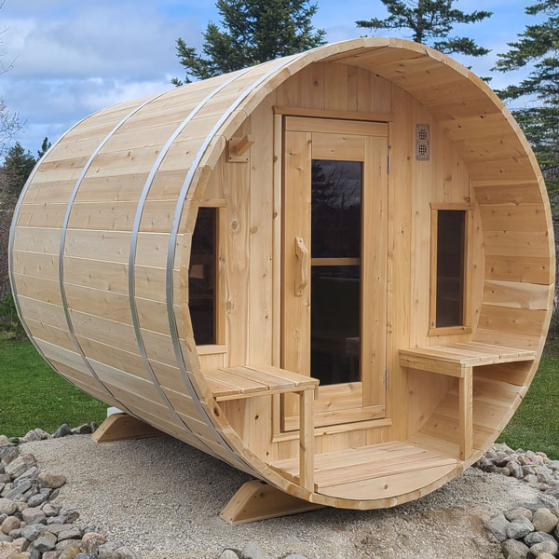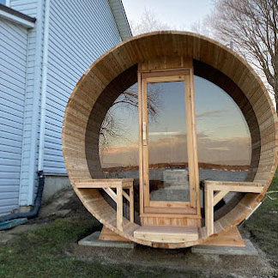

Model: CT Tranquility and CT Tranquility from the Canadian Timber Collection

Number of people: 4-5

Wood: Eastern White Cedar, Knotty (including benches)

Overall size: 6 1/2’ x 8’ with an 18” porch

Bench Configuration: Two single tier side wall benches with flat floor

Window: Two windows either side of door

Tranquility MP Halfmoon glass: Bronze, double pane 5mm

Roof:

Black asphalt roof

Black metal roof

Heater options:

Electric or wood (back wall only)

Wifi electric or non-wifi electric

Electric requires 220 volt and typically 30 or 40 amp, depending on the size of heater

5- year Residential Warranty

**Dundalk LeisureCraft Inc.**

318448 8th Line, Melancthon, Ontario Canada L9V 2K3

Ph: 519-923-9813 | Fax: 866-458-7583 | Web: [www.leisurecraft.com](http://www.leisurecraft.com)